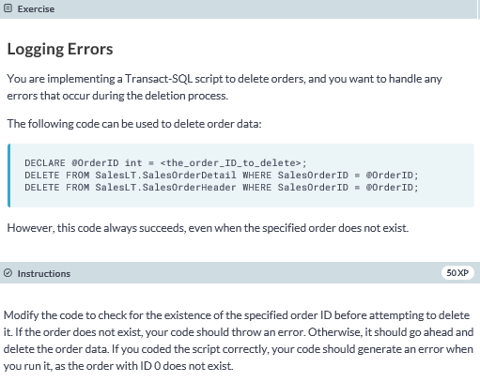

**DECLARE @OrderID int = 0**

**-- Declare a custom error if the specified order doesn't exist**

**DECLARE @error VARCHAR(30) = 'Order #' + cast(@OrderID as VARCHAR) + ' does not exist';**

**IF NOT EXISTS (SELECT * FROM SalesLT.SalesOrderHeader WHERE SalesOrderID = @OrderID)**

**BEGIN**

**THROW 50001, @error, 0;**

**END**

**ELSE**

**BEGIN**

**DELETE FROM SalesLT.SalesOrderDetail WHERE SalesOrderID = @OrderID;**

**DELETE FROM SalesLT.SalesOrderHeader WHERE SalesOrderID = @OrderID;**

**END**

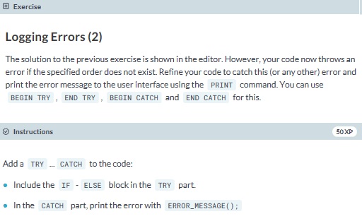

**DECLARE @OrderID int = 71774**

**DECLARE @error VARCHAR(30) = 'Order #' + cast(@OrderID as VARCHAR) + ' does not exist';**

**-- Wrap IF ELSE in a TRY block**

**BEGIN TRY**

**IF NOT EXISTS (SELECT * FROM SalesLT.SalesOrderHeader WHERE SalesOrderID = @OrderID)**

**BEGIN**

**THROW 50001, @error, 0**

**END**

**ELSE**

**BEGIN**

**DELETE FROM SalesLT.SalesOrderDetail WHERE SalesOrderID = @OrderID;**

**DELETE FROM SalesLT.SalesOrderHeader WHERE SalesOrderID = @OrderID;**

**END**

**END TRY**

**-- Add a CATCH block to print out the error**

**BEGIN CATCH**

**PRINT ERROR_MESSAGE();**

**END CATCH**

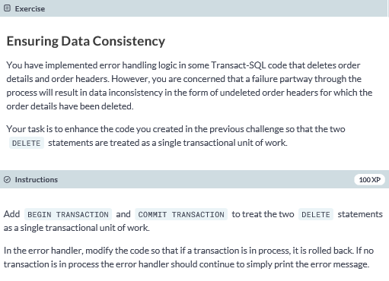

**DECLARE @OrderID int = 0**

**DECLARE @error VARCHAR(30) = 'Order #' + cast(@OrderID as VARCHAR) + ' does not exist';**

**BEGIN TRY**

**IF NOT EXISTS (SELECT * FROM SalesLT.SalesOrderHeader WHERE SalesOrderID = @OrderID)**

**BEGIN**

**THROW 50001, @error, 0**

**END**

**ELSE**

**BEGIN**

**BEGIN TRANSACTION**

**DELETE FROM SalesLT.SalesOrderDetail**

**WHERE SalesOrderID = @OrderID;**

**DELETE FROM SalesLT.SalesOrderHeader**

**WHERE SalesOrderID = @OrderID;**

**COMMIT TRANSACTION**

**END**

**END TRY**

**BEGIN CATCH**

**IF @@TRANCOUNT > 0**

**BEGIN**

**ROLLBACK TRANSACTION;**

**END**

**ELSE**

**BEGIN**

**PRINT ERROR_MESSAGE();**

**END**

**END CATCH**